Easy Triangle Shawl - Knit

The Prayer: Lord, as I begin this shawl bless my hands that will do your work and touch my heart that I will hear your voice. I pray that the one who will wear this shawl be wrapped in your love, graced with your peace, and filled with your joy. Let it be done according to your will and to your glory. Amen

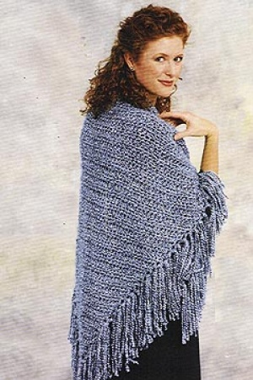
If you know the person for whom the shawl in being made, be specific in your prayers for that person. Lift their needs to the Lord trusting in the words of Mark 11:24: Therefore I tell you, whatever you ask in prayer, believe that you have received it, and it will be yours.
Provided for you by the Prayer Shawl Ministry of Apostles Lutheran Church, Peoria, AZ

SKILL LEVEL: Easy
SIZE: One Size
Finished width 64 inches
Length 35 inches (not including fringe)
CORRECTIONS: None GAUGE: 9 sts + 17 rows = 4 inches (10 cm) with size 13 (9 mm) knitting needles. BE SURE TO CHECK YOUR GAUGE. When you match the gauge in a pattern, your project will be the size specified in the pattern and the materials specified in the pattern will be sufficient. If it takes you fewer stitches and rows to make a 4 in. [10 cm] square, try using a smaller size hook or needles; if more stitches and rows, try a larger size hook or needles. NOTES: Editor’s Note: When creating fringe using Homespun please note that because of the texture of the yarn the fringe will fray when cut. If you prefer a non-frayed look you can knot the ends, knit or crochet a fringe, or use hairspray or fray check.
SHAWL
Cast on 3 sts.
Row 1 Knit
Row 2 Knit 1, yarn over, k to end.
Repeat row 2 until piece measures 35 inches from cast on edge - 143 sts.
Bind off loosely.
FINISHING
Cut yarn for fringe 16 inches long. Add fringe in spaces along the side edges of shawl.

Lion Brand® Homespun®

Pattern #: khs-triangleShawl

~The prayer of righteous person has great power as it is working. James 5:16 ~

~And I will do whatever you ask in my name, so that the Father may be glorified in the Son. You may ask me for anything in my name, and I will do it. John 14:13-14 ~

