“Behind me and before me you encircle me and rest your hand upon me.” Psalm 139:5
The Prayer: Lord, as I begin this shawl bless my hands that will do your work and touch my heart that I will hear your voice. I pray that the one who will wear this shawl be wrapped in your love, graced with your peace, and filled with your joy. Let it be done according to your will and to your glory. Amen

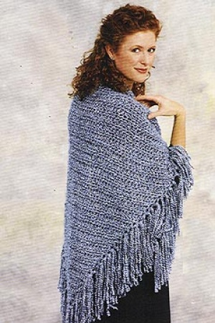
Be specific in your prayers if you know the person for whom the shawl is being made. Lift their needs to the Lord trusting in the words of Mark 11:24: Therefore I tell you, whatever you ask in prayer, believe that you have received it, and it will be yours.
Provided for you by the Prayer Shawl Ministry of Apostles Lutheran Church, Peoria, AZ

Lion Brand® Homespun®

Pattern #: 81052AD

Easy Triangle Shawl

Finished width 64 inches approx. Length 35 inches (not including fringe) Materials: 3 balls Homespun ‘N’ Crochet hook 9 Gauge: 9 sts + 6 rows = 4 inches (10 cm) with size N (9 mm) crochet hook. BE SURE TO CHECK YOUR GAUGE. When you match the gauge in a pattern, your project will be the size specified in the pattern and the materials specified in the pattern will be sufficient. If it takes you fewer stitches and rows to make a 4 in. [10 cm] square, try using a smaller size hook or needles; if more stitches and rows, try a larger size hook or needles. Notes: Chain 3 at beg of each row counts as hdc and ch 1.Editor’s Note: When creating fringe using Homespun please note that because of the texture of the yarn the fringe will fray when cut. If you prefer a non-frayed look you can knot the ends, knit or crochet a fringe, or use hairspray or fray check .Apostles’ Prayer Shawl Note: Knotting the ends of the fringe provides another opportunity to pray – a prayer for each knot!
SHAWL
Chain 4, slip stitch in 1st chain to form circle, ch 3.
Row 1
Work 3 hdc into circle, ch 1, 1 hdc into circle, ch 3, turn - (5 hdc, 2 ch-1 space).
Row 2
Skip ch-1 space, 2 hdc into next hdc, 1 hdc into hdc, 2 hdc into next hdc, ch 1, hdc into ch-3 space, ch 3, turn - (7 hdc, 2 ch-1 space).
Row 3
Skip ch-1 space, 2 hdc into next hdc, 1 hdc into each of next 3 hdc, 2 hdc into next hdc, ch 1, hdc into ch-3 space, ch 3, turn - (9 hdc, 2 ch-1 space).
Row 4
Skip ch-1 space, 2 hdc into next hdc, 1 hdc into each of next 5 hdc, 2 hdc into next hdc, ch 1, hdc into ch-3 space, ch 3, turn - (11 hdc, 2 ch-1 space).
Cont in pattern, increasing 1 hdc at beg and end of each row (2 hdc per row) until shawl measures 35" inchesfrom lower edge.
FINISHING: Cut yarn for fringe 16 inches long. Add fringe in spaces on side edges of shawl.

