***Mary Otte***

***623-412-3284***

[***Rebel6883@aol.com***](mailto:Rebel6883@aol.com)

***Susan Thomas***

[***414sthomas@gmail.com***](mailto:414sthomas@gmail.com)

***Judy Larrieu***

[***jll625@netzero.net***](mailto:jll625@netzero.net)

***Apostles Lutheran Church***

***623-979-3497*** [***apostles@integra.net***](mailto:apostles@integra.net)

**Praise Reports**

**It’s all about the prayer**

**You are Invited**

*“I wrapped myself in it and immediately felt the peace of all your prayers.”*

*Your prayers are important*.”

*“One of our patients at the end of life received on of your shawls and as a result accepted Christ as their savior and was baptized.”*

If you would like to request a prayer shawl contact the following people, or the church office**. All requests are confidential.**

Marriages Graduation

Births Crisis

Confirmation Illness

Consolation Friendship

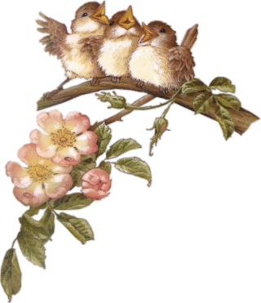

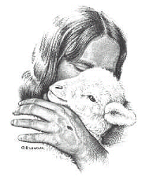

**Behind me and before me you encircle me and rest your hand upon me. Psalm 139:5**

Prayer shawls are made with prayer. Prayer before the shawl is begun, during its creation, at the completion of the shawl and as it is presented to the recipient of those prayers. Rejoice and pray giving thanks – that’s what prayer shawls are all about.

When are prayer shawls needed?

**What are prayer shawls?**

Prayer Shawls are a reminder of God’s steadfast love and abundant mercy. They are a ‘hug’ from Jesus. They are proof that we are loved. They carry the prayers that our broken hearts cannot pray. They sing the praises with us in times of rejoicing. They are evidence that God’s love continually encircles his children.

**Prayer Shawl Ministry It’s all about the prayer**

It’s all about the prayer

*Would you like to join us in making prayer shawls?*

Tuesday mornings at 8:30 am or Wednesday evenings at 6:30pm in

Fellowship Hall.

Not sure this is for you? We will provide patterns and instruction. Join us for this time of prayer and fellowship as we work.