Wheelchair Wrap
The Prayer: Lord, as I begin this shawl bless my hands that will do your work and touch my heart that I will hear your voice. I pray that the one who will wear this shawl be wrapped in your love, graced with your peace, and filled with your joy. Let it be done according to your will and to your glory. Amen
Be specific in your prayers if you know the person for whom the shawl is being made. Lift their needs to the Lord trusting in the words of Mark 11:24: Therefore I tell you, whatever you ask in prayer, believe that you have received it, and it will be yours.

Author: Susan A. Coes
Introduction: This little wrap was designed especially for the elderly – particularly those confined to wheelchairs or to bed. The short length prevents it from getting caught in wheels. The shape helps keep in on the shoulders where many elderly get cold. Being open down the front makes it easy for medical personnel to access arms for blood pressure reading and such. Materials list: 12 ounces of worsted weight yarn; H hook finished size: Approximately 18 inches long (down the center back) and approximately 80 inches around the bottom edge. Gauge: 14 dc = 4 inches Notes: V stitch = 1 dc, ch 1, 1 dc
Provided for you by Prayer Shawl Ministry of Apostles Lutheran Church, Peoria, AZ
The author has licensed this page under a Creative Commons License. Some rights reserved
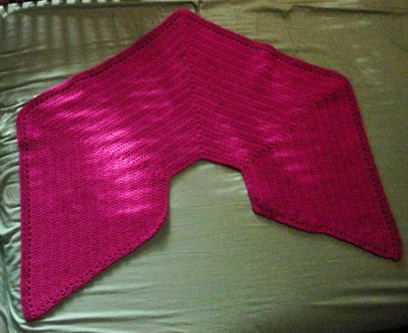

The Pattern
Chain 54
Row 1: dc in 3rd ch from hook, ch 1, 2 dc in next ch, *dc in next 11 ch, v st in next ch, repeat from * 2 times, dc in next 11 ch, 2 dc in next ch, ch 1, 1 dc in each of last 2 ch, ch 2, turn (58 dc and 5 ch 1 spaces)
Row 2: dc in next dc, ch 1, 2 dc in next dc, *dc in next 13 dc, V st in ch1 space, repeat from * 2 times, dc in next 13 dc, 2 dc in next dc, ch 1, dc in last dc and in top of turning ch, ch2, turn (8 sts increased).
Rows 3 - 28: repeat row 2, following established pattern, always increasing the number of dc between V sts by 2 (each row increases by a total of 8 sts).
Row 29: dc in next dc, ch 1, skip ch 1 space, dc in next dc, *ch 1, skip 1 dc and dc in next st, repeat from * to V st in previous row, ch 1, V st in ch 1 space of V st, ch 1, skip next dc, dc in next dc repeat from * across row to last dc. Ch 1, skip ch 1 space, dc in next dc, dc in last dc and in top of turning ch, ch 2, turn
Row 30: dc in each dc and ch 1 space across, end off, weave in ends.
The author has licensed this page under a Creative Commons License. Some rights reserved.

